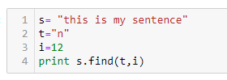
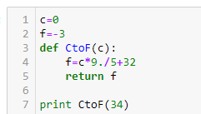
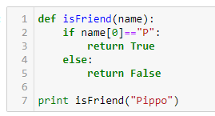
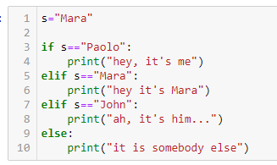
Exercises:
Build flowcharts for these pieces of code based on your own programs (your own, not mine! Use mine only if your code is wrong AND has less than 3 lines)
- Python02exe: Assume A is a float variable containing a float number with several digits after the dot. Build a Python code which prints A rounded down to two decimal digits.
- Python03exe: compare_the_two
- Python03exe: isLeapYear
Use draw.io/diagrams.net or another program you like or with pencil on paper. In either case please send me either a PDF or an image and, if possible, include the piece of code.

